BAN 502 – Phase 1 Exploratory Analysis

1. Load Data
train <- read.csv("C:/Users/broml/Downloads/train.csv")
head(train)
## id product_code loading attribute_0 attribute_1 attribute_2 attribute_3
## 1 0 A 80.10 material_7 material_8 9 5
## 2 1 A 84.89 material_7 material_8 9 5
## 3 2 A 82.43 material_7 material_8 9 5
## 4 3 A 101.07 material_7 material_8 9 5
## 5 4 A 188.06 material_7 material_8 9 5
## 6 5 A 75.35 material_7 material_8 9 5
## measurement_0 measurement_1 measurement_2 measurement_3 measurement_4
## 1 7 8 4 18.040 12.518
## 2 14 3 3 18.213 11.540
## 3 12 1 5 18.057 11.652
## 4 13 2 6 17.295 11.188
## 5 9 2 8 19.346 12.950
## 6 11 4 0 17.564 13.721
## measurement_5 measurement_6 measurement_7 measurement_8 measurement_9
## 1 15.748 19.292 11.739 20.155 10.672
## 2 17.717 17.893 12.748 17.889 12.448
## 3 16.738 18.240 12.718 18.288 12.715
## 4 18.576 18.339 12.583 19.060 12.471
## 5 16.990 15.746 11.306 18.093 10.337
## 6 16.594 NA 11.592 20.810 10.622
## measurement_10 measurement_11 measurement_12 measurement_13 measurement_14
## 1 15.859 17.594 15.193 15.029 NA
## 2 17.947 17.915 11.755 14.732 15.425
## 3 15.607 NA 13.798 16.711 18.631
## 4 16.346 18.377 10.020 15.250 15.562
## 5 17.082 19.932 12.428 16.182 12.760
## 6 14.904 19.107 13.327 15.354 19.251
## measurement_15 measurement_16 measurement_17 failure
## 1 13.034 14.684 764.100 No
## 2 14.395 15.631 682.057 No
## 3 14.094 17.946 663.376 No
## 4 16.154 17.172 826.282 No
## 5 13.153 16.412 579.885 No
## 6 NA 17.625 832.902 No
The dataset contains 26 variables including product characteristics, measurement values, and the response variable failure.

2. Missing Value Analysis
colSums(is.na(train))
## id product_code loading attribute_0 attribute_1
## 0 0 250 0 0
## attribute_2 attribute_3 measurement_0 measurement_1 measurement_2
## 0 0 0 0 0
## measurement_3 measurement_4 measurement_5 measurement_6 measurement_7
## 381 538 676 796 937
## measurement_8 measurement_9 measurement_10 measurement_11 measurement_12
## 1048 1227 1300 1468 1601
## measurement_13 measurement_14 measurement_15 measurement_16 measurement_17
## 1774 1874 2009 2110 2284
## failure
## 0
Most measurement variables contain some missing values. This suggests that handling missing data may be important in Phase 2 predictive modeling.

3. Failure Distribution
table(train$failure)
##
## No Yes
## 20921 5649
prop.table(table(train$failure))
##
## No Yes
## 0.7873918 0.2126082
ggplot(train, aes(x = factor(failure))) +
geom_bar(fill = "steelblue") +
theme_minimal() +
labs(title = "Failure Distribution",
x = "Failure (0 = No, 1 = Yes)",
y = "Count")
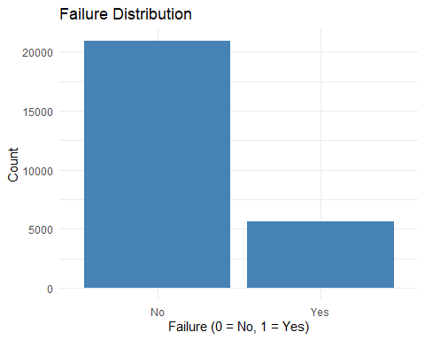
There is not a statistically large correlation between failed and non-failed products. This points to predictive modeling not being strongly favoring of one or the other.

4. Loading vs Failure
ggplot(train, aes(x = factor(failure), y = loading)) +
geom_boxplot(fill = "orange") +
theme_minimal() +
labs(title = "Loading vs Failure",
x = "Failure",
y = "Loading")
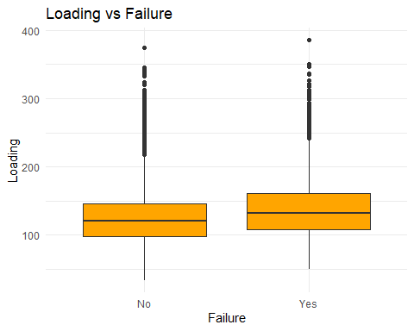
Products that failed were slightly higher in loading than those which did not. This would imply that loading could be a real predictor of failure.

5. Measurement Variables vs Failure

Measurement 0
ggplot(train, aes(x = factor(failure), y = measurement_0)) +
geom_boxplot(fill = "green") +
theme_minimal() +
labs(title = "Measurement 0 vs Failure",
x = "Failure")
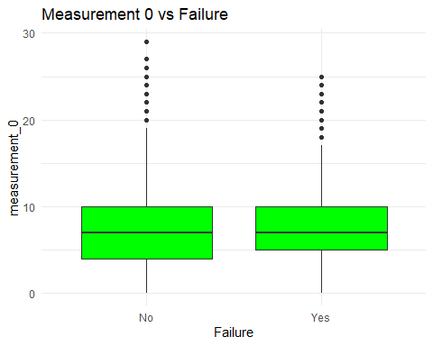

Measurement 5
ggplot(train, aes(x = factor(failure), y = measurement_5)) +
geom_boxplot(fill = "purple") +
theme_minimal() +
labs(title = "Measurement 5 vs Failure",
x = "Failure")
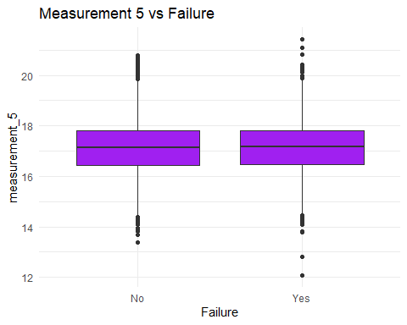

Measurement 10
ggplot(train, aes(x = factor(failure), y = measurement_10)) +
geom_boxplot(fill = "brown") +
theme_minimal() +
labs(title = "Measurement 10 vs Failure",
x = "Failure")
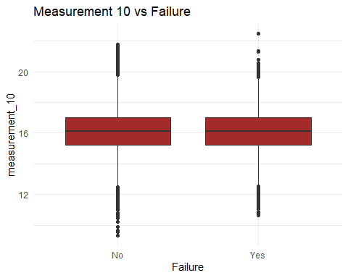
All these graphs above show very little predictive statistical information.

6. Key Findings
- Failure distribution is modestly balanced.
- Loading shows noticeable differences between failure groups.
- Certain measurement variables (measurement_0, measurement_5, measurement_10) show differentiation patterns.
- Missing data exists in measurement variables and must be addressed at some point.
Overall, loading and selected measurement variables appear to be the strongest potential predictors.

